# Bitbot Test 1

In which category will you find the “show LEDs” block?

A. LED

B. Input

C. Basic

D. Variables

ANSWER: C

What does the term ‘decomposition’ mean?

A. Breaking down the problem into small steps

B. Removing unnecessary detail from the problem

C. Identifying patterns which could be used in the solution

D. Identifying step by step instructions to solve the problem

ANSWER: A

What is an algorithm?

A. A piece of computer code which solves a problem

B. A set of step by step instructions to solve a problem

C. A way of removing unnecessary detail so you can focus on the problem

D. A hex file

ANSWER: B

What is an ultrasonic sensor an example of?

A. An input device

B. An output device

C. An input and output device

D. A storage device

ANSWER: A

Jonny wants to detect the distance from the bitbot to a solid object. Which sensor should he use?

A. Light sensor

B. Temperature sensor

C. Ultrasonic sensor

D. Accelerometer

ANSWER: C

When using new hardware with a microbit the relevant library has to be installed. Which option should be selected to add a new code library?

A. Functions

B. Arrays

C. Extensions

D. Control

ANSWER: C

What is the name of the device below?

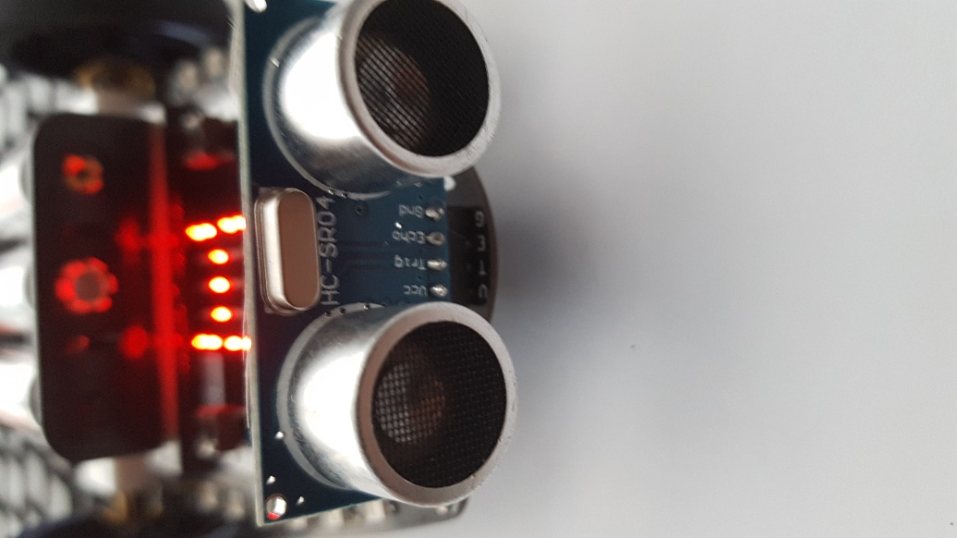

A. Light sensor

B. Ultrasonic sensor

C. Speaker

D. Servo

ANSWER: B

A bit:bot has been programmed to measure the light in a room. The relevant sensor has returned a value of 1000. What does this mean?

A. The sensor isn’t working

B. The code is incorrect

C. It is very dark

D. It is very bright

ANSWER: D

The code below is used to detect distance at certain time periods. How often will the sensor measure the distance?

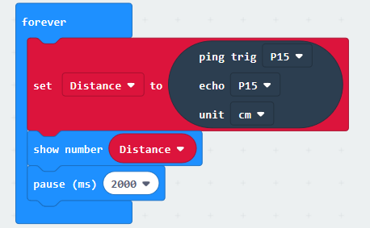

A. Every 200 seconds

B. Every 20 seconds

C. Every 2 seconds

D. Every 0.2 seconds

ANSWER: C

What is the name of the device which is circled below?

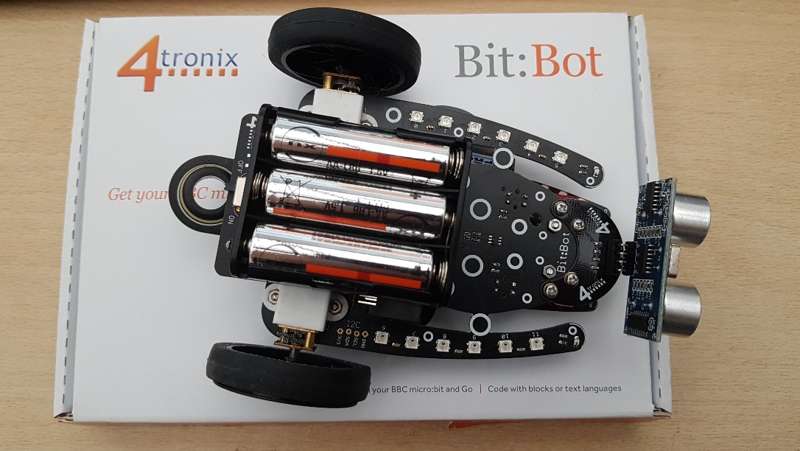

A. Motor

B. Pen holder

C. Neopixel

D. Ultrasonic sensor

ANSWER: B

What is the green code block below an example of?

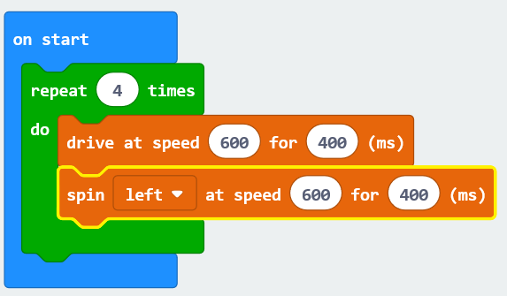

A. Sequence

B. Selection

C. Rotation

D. Iteration

ANSWER: D

The code below creates a shape which has 8 sides. What is the name of this shape?

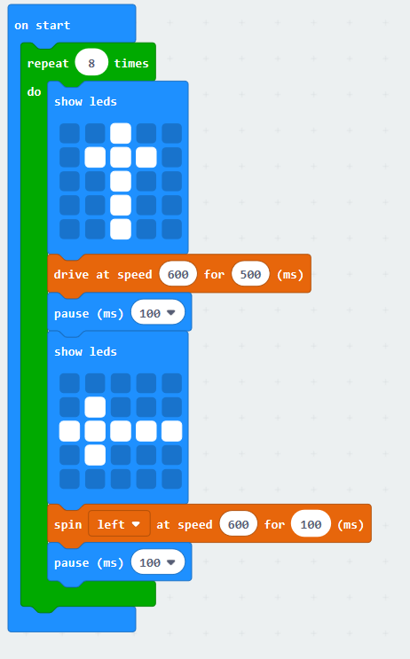

A. A square

B. A pentagon

C. An octagon

D. A triangle

ANSWER: C

How many times will the code below need to be looped to create a square?



A. 2

B. 3

C. 4

D. 8

ANSWER: C

Which of the following statements correctly describes the block of code below?

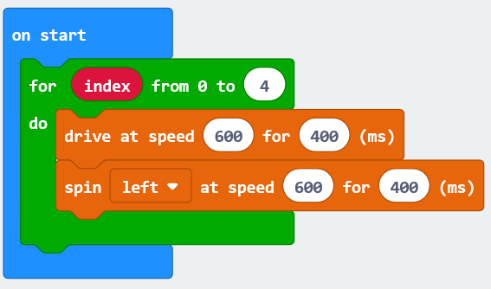

A. It contains a count controlled loop

B. It contains a condition controlled loop

C. It only uses examples of sequence

D. It only uses examples of selection

ANSWER: A

A self-driving car has been designed so that if a pedestrian steps out it is detected by the car and break is automatically applied. What is applying the break an example of?

A. An input

B. An output

C. A process

D. A sensor

ANSWER: B

Jerome is designing a new computer game. He has split the overall task into the following sub tasks – character creation, movement, gameplay and scoring. What is this an example of?

A. Decomposition

B. Algorithmic thinking

C. Pattern identification

D. Abstraction

ANSWER: A

Digby is a fitness fanatic. Before running on a treadmill he sets the speed to 10mph. What is this step known as?

A. Input

B. Process

C. Output

D. Storage

ANSWER: A

To make the bitbot move you have to program the two motors. What are the motors examples of?

A. Output devices

B. Input devices

C. Input and output devices

D. Processes

ANSWER: A

Which package do you need to add to make code in order to use the ultrasonic sensor?

A. Ultrasonic

B. Sonar

C. Bitbot

D. Neopixel

ANSWER: B